Alice in Wonderland, part I
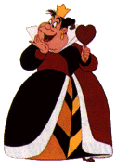
1. The Queen of hearts has decided, to make tarts for her beloved husband. But when she is about to start, she suddenly notices that somebody stole her eggs.
“The thief must be found at once!” she shouts and of course an investigation starts. They find the eggs in the house of the Duchess and her cook.

The duchess says: The cook is not guilty.
The cook however is nasty and says: It was the Duchess.
Later the court finds out that the thief lied. Who was it?

2. The eggs have just been found when suddenly the flour disappears from the Queens kitchen. The queen is enraged and another hectic search starts. Eventually they find the flour on the table at which the March Hare the Hatter and the Dormouse are sitting. The interrogation goes as follows:

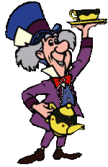
It wasn’t me!
It was one of us, but not me!
At least one of the two is telling the truth.
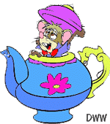
The court also finds out, that not both the March Hare and the Dormouse told the truth.
Which one of the three stole the flour?
3. When the Queen finds out, that the sugar is also missing she gets absolutely furious. The situation gets very dangerous, when the sugar turns out to be on the Mad Tea-Party’s table, as well.
This time the March Hare says that the Hatter stole the sugar.
Unfortunately I forgot what the other two said, but I remember that only the thief told the truth. Who was it this time?

